**Command cron:**

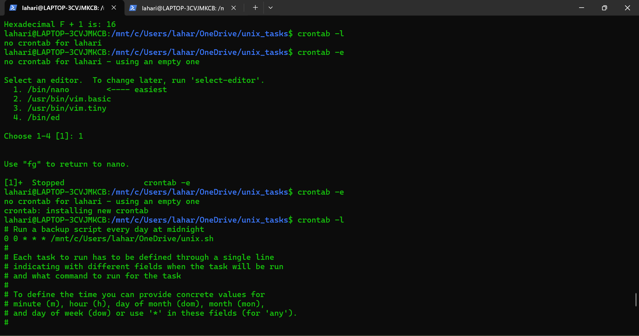

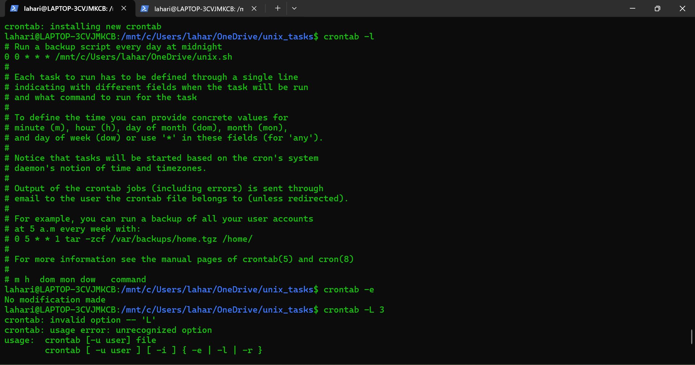

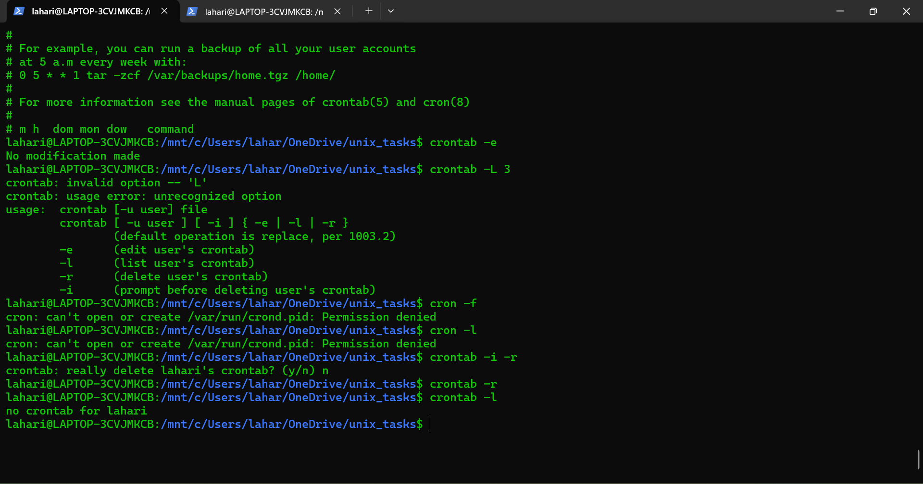

**Command diff:**

--normal

output a normal diff (the default)

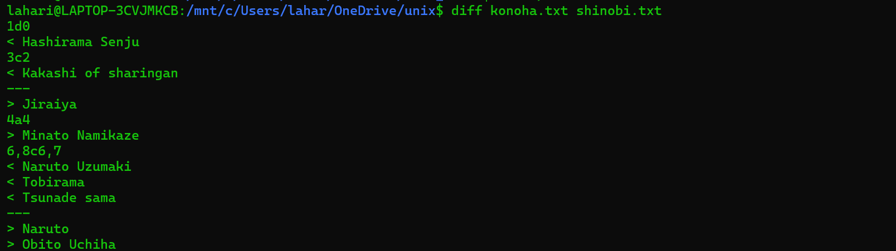

-q, --brief

report only when files differ



-s, --report-identical-files

report when two files are the same

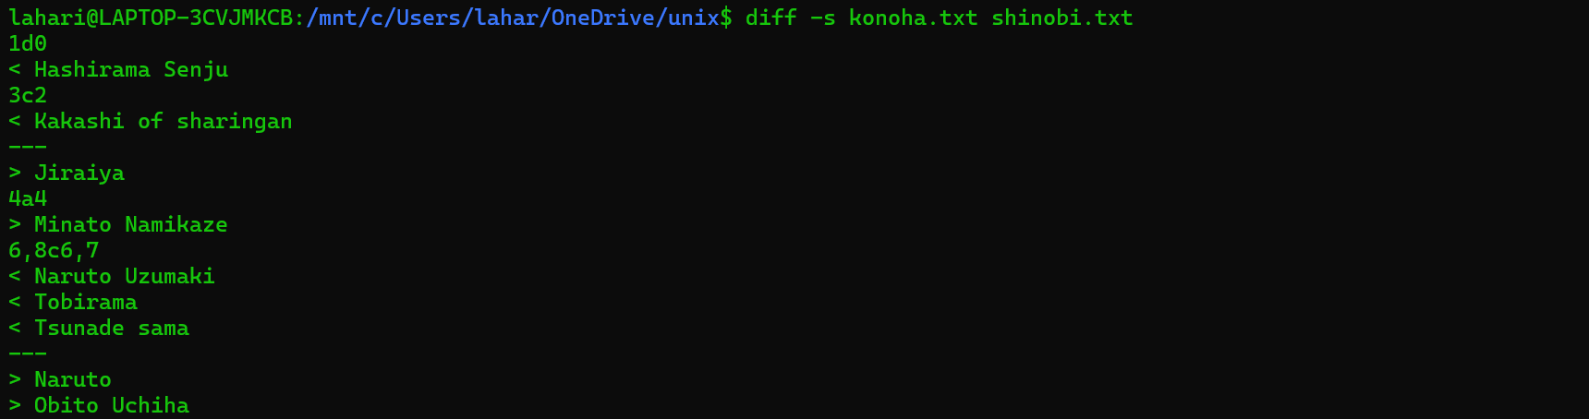

-c, -C NUM, --context[=NUM]

output NUM (default 3) lines of copied context

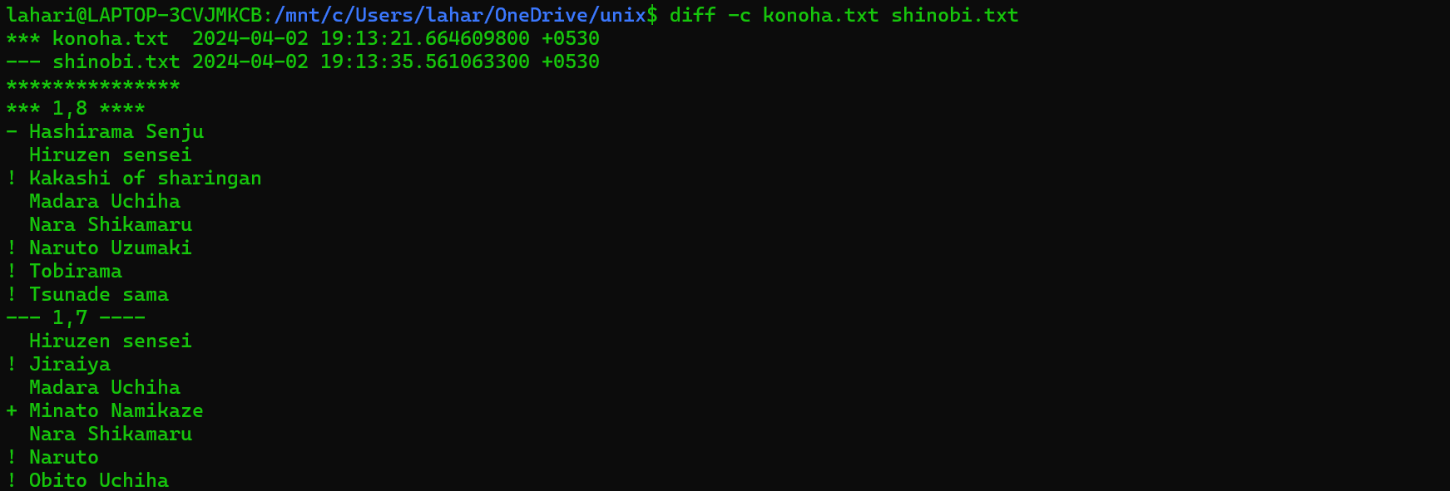

-u, -U NUM, --unified[=NUM]

output NUM (default 3) lines of unified context

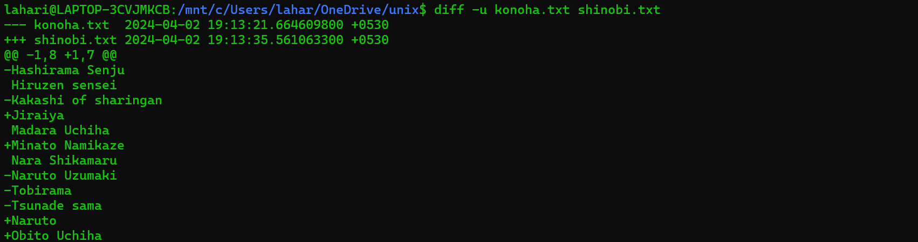

-e, --ed

output an ed script

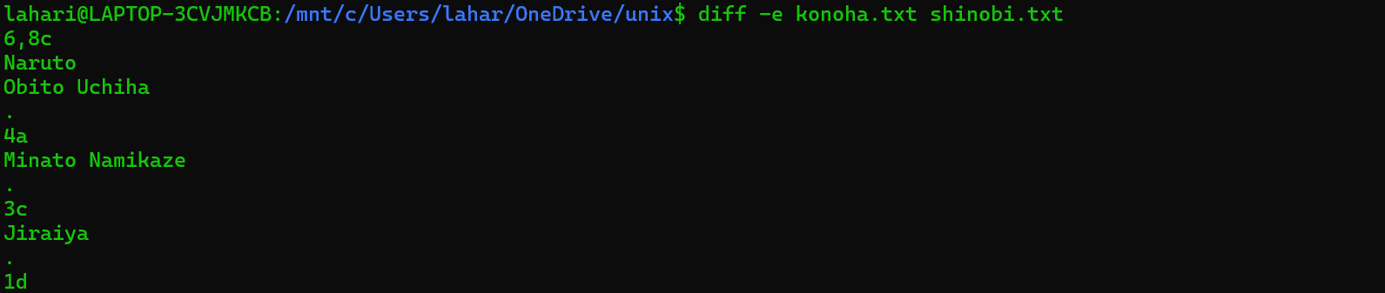

-n, --rcs

output an RCS format diff

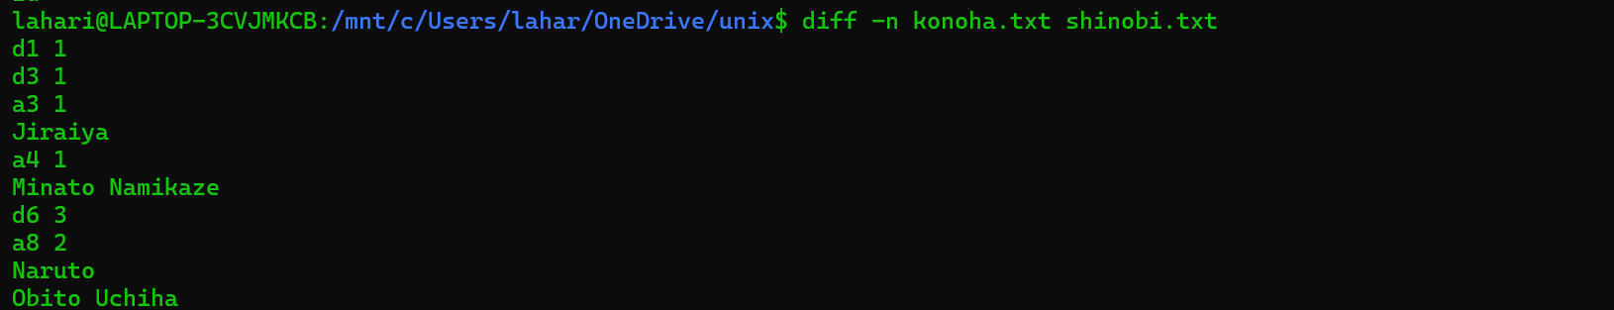

-y, --side-by-side

output in two columns

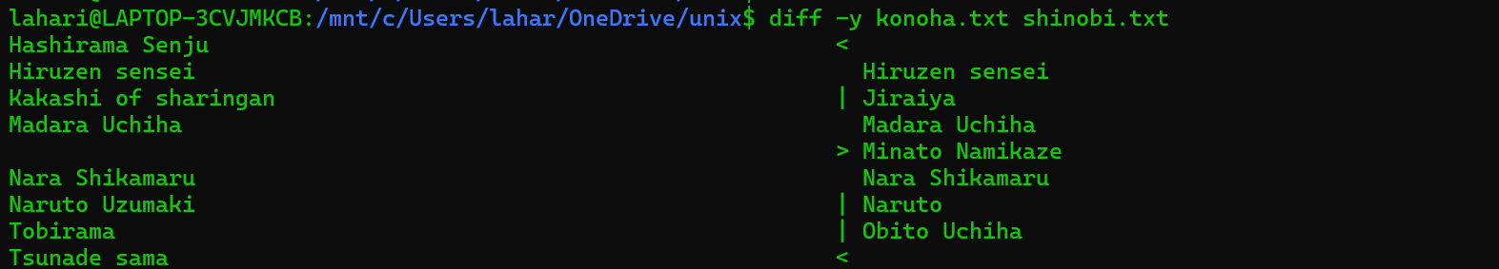

-W, --width=NUM

output at most NUM (default 130) print columns

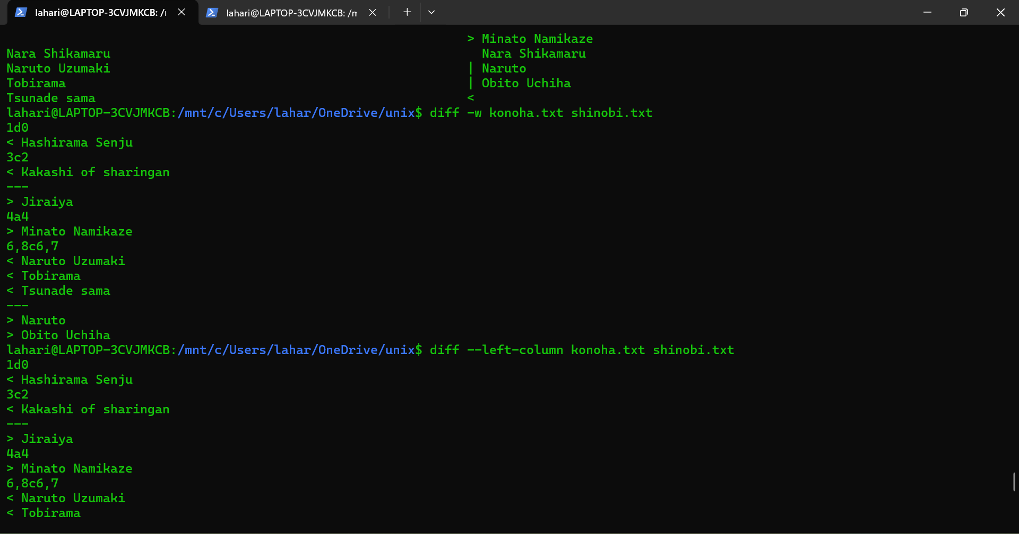

--left-column

output only the left column of common lines

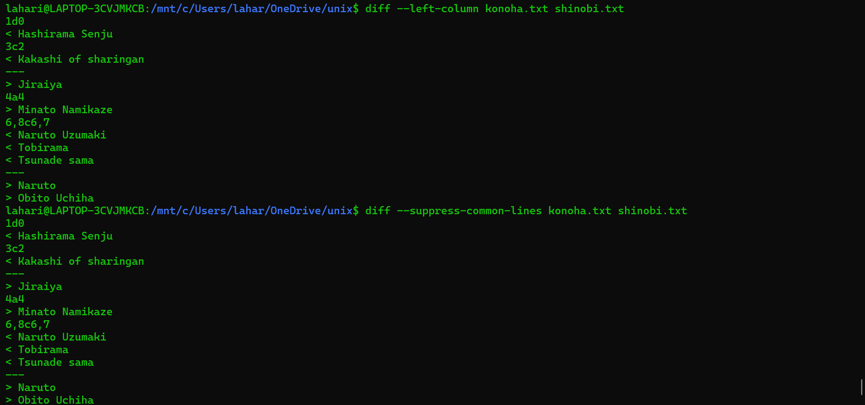

--suppress-common-lines

do not output common lines



-p, --show-c-function

show which C function each change is in

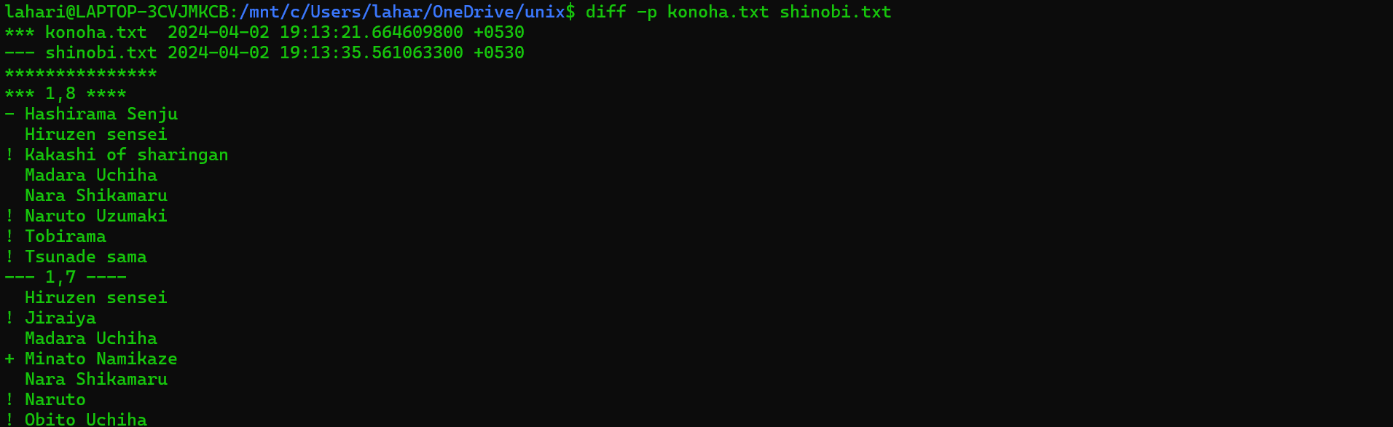

For more, can use “man diff”

**Command chown:**

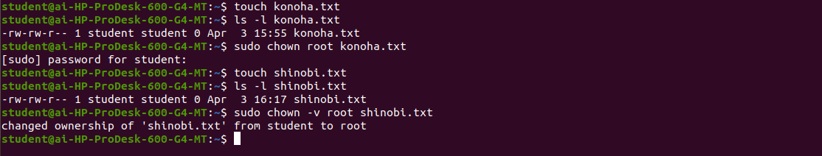

**Command dd:**

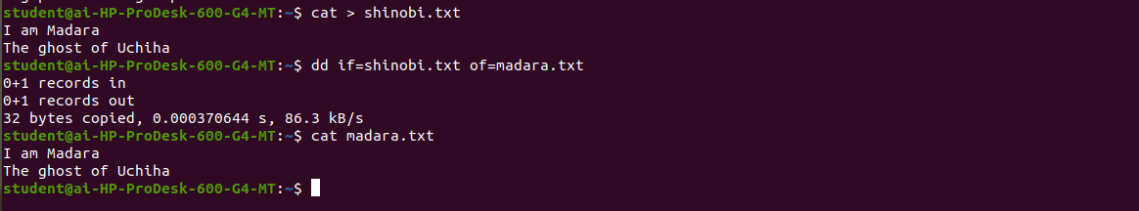

**Command finger:**

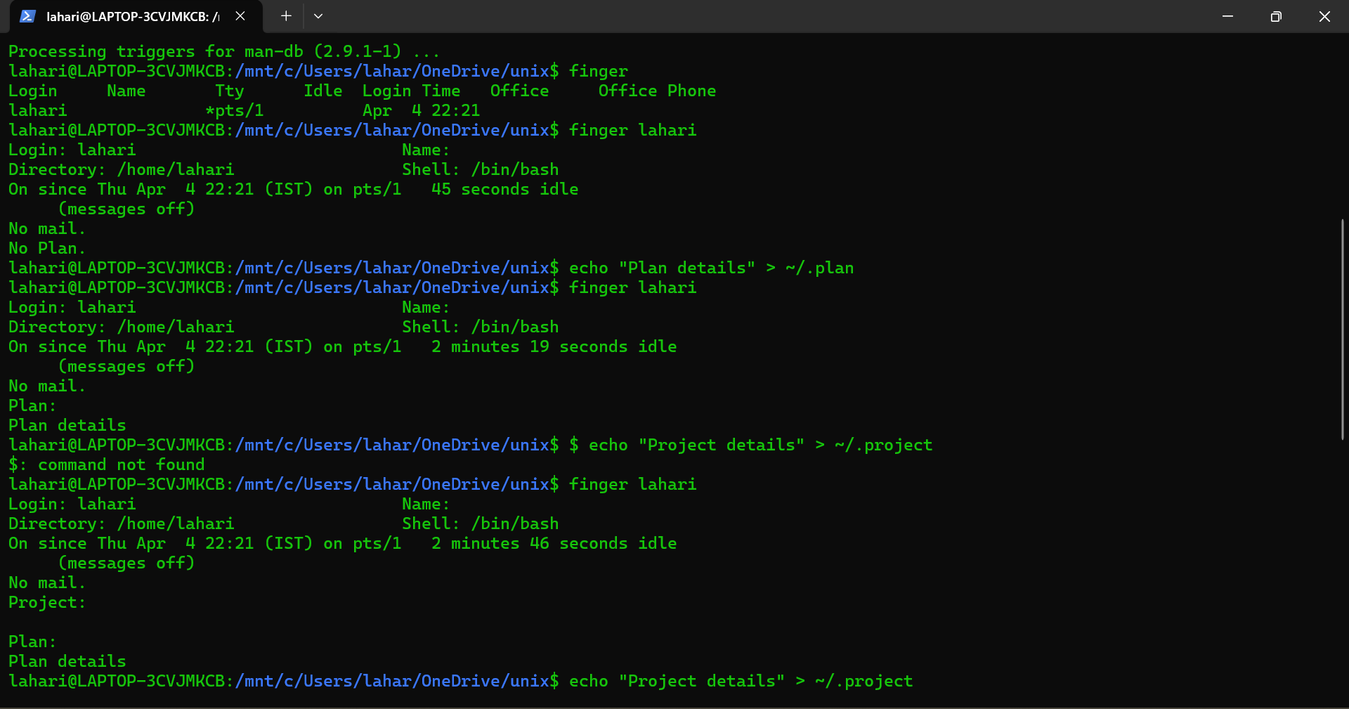

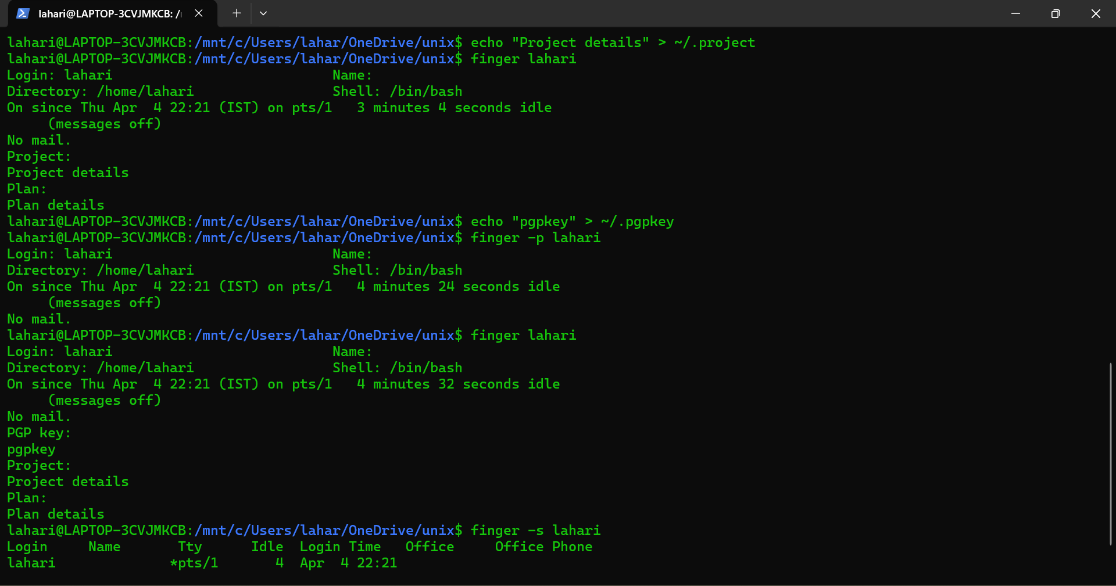

**Command find:**



